**Day 3 - API Integration Report – QuickBite**

**- API Integration Process:**

1. **Sanity Project Setup:**

* Created a Sanity project for content management.
* Generated an API token in the project settings for secure access.
* Configured .env.local file in Next.js project to store the API token and project ID securely.

1. **Data Migration:**
   * Cloned the GitHub repository containing migration scripts and schemas for your API.
   * Modified or validated the schemas (e.g., added images array and stock fields in the foods schema) to align with data structure.
   * Logged in to the Sanity Studio to access and verify schema definitions.
   * Imported API data using the provided migration script in the given repository. Successfully migrated the Food and Chef data to Sanity CMS.
2. **Fetching Data Using GROQ Queries:**
   * + Created GROQ query functions to fetch data directly from Sanity. Queries included fetching all categories, categories along with food items, and single food item details.
     + Utilized these queries in the components of my Next.js website.
3. **Frontend Data Integration:**
   * Integrated the fetched data into the frontend components.
   * Used the map function to display the data dynamically in HTML, such as showing lists of food items or categories.
   * Ensured the data was rendered correctly by testing API calls and visualizing the data in the browser.
4. **Testing and Validation:**

* Verified the integration by ensuring the frontend displayed the data as intended.
* Populated Sanity CMS fields were cross-checked to confirm the data migration's accuracy.

**- Adjustment made to schemas:**

1. **Added images array field in foods schema:**

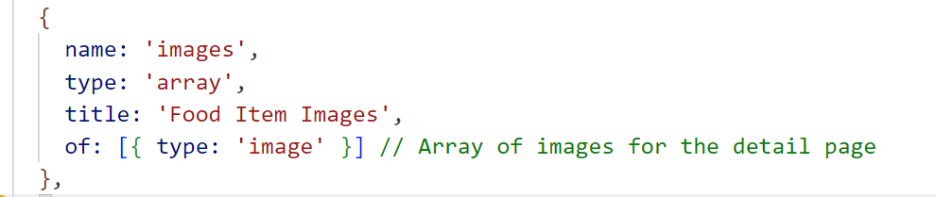

1. **Added stock field for inventory management in foods schema:**

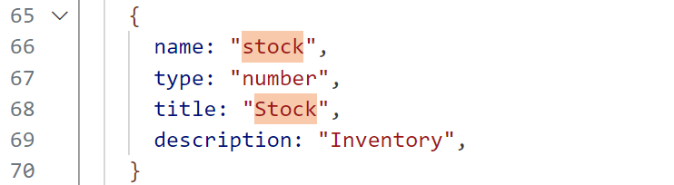

**- Migration steps and tools used:**

1. **Setup sanity project in the frontend Next JS website:**

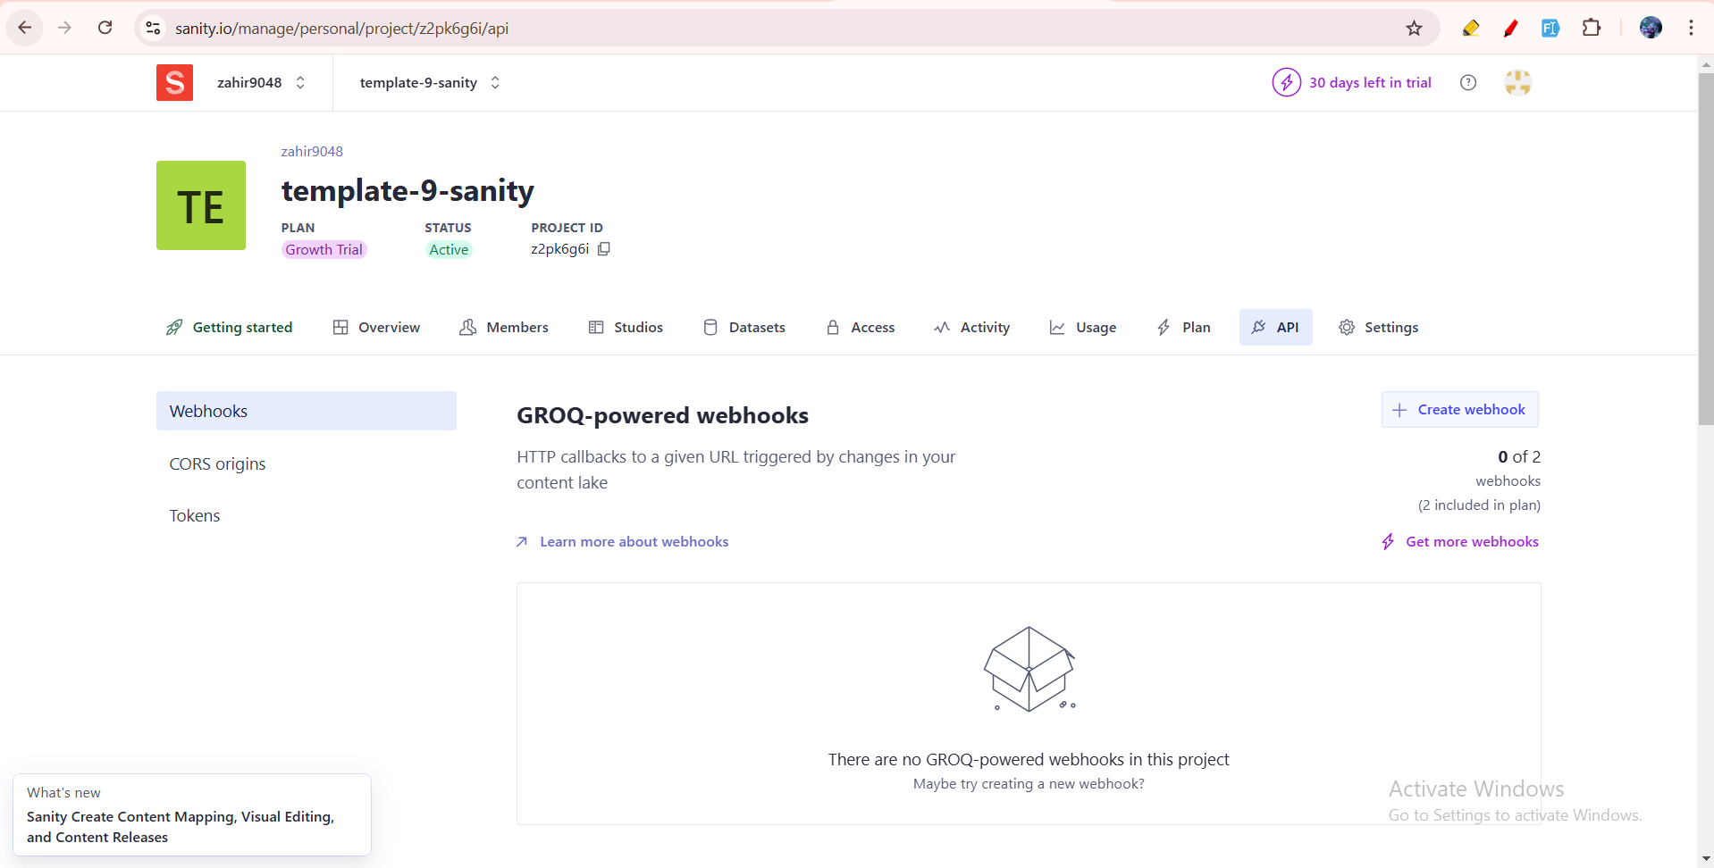

Sanity Project created.

1. **Generate editor access API token in project settings:**

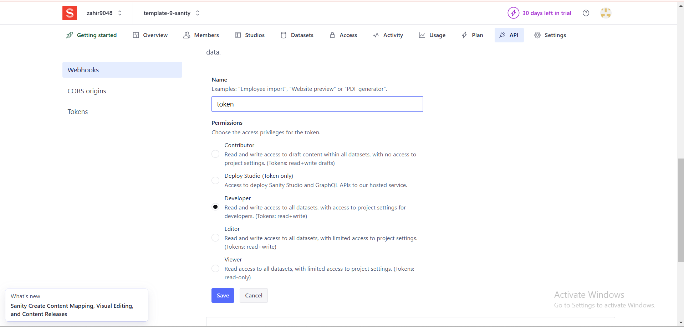

1. **Copy and paste the API token in .env.local file and pass that token in client.ts**

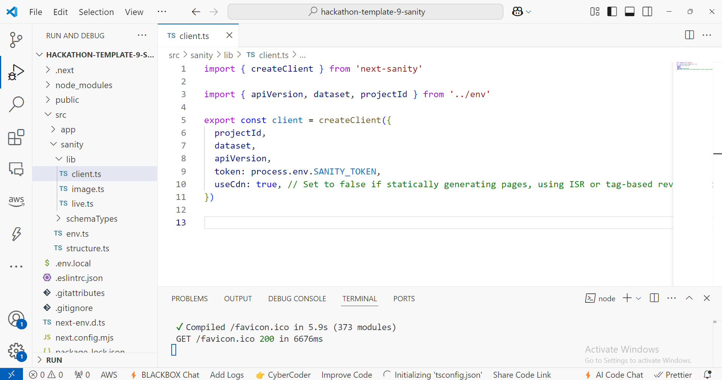

1. **Now, clone the sir Mubashir GitHub repo which contains the migration script for API’s and schemas.**

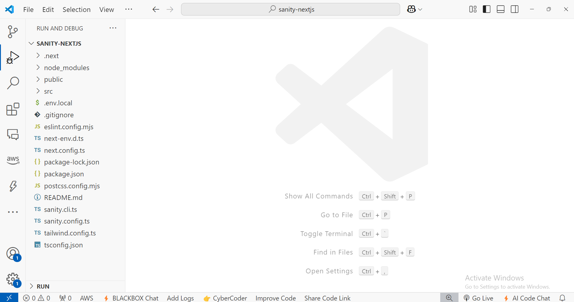

1. **Now create .env.local file and set project id and generated api token in .env.local file.**

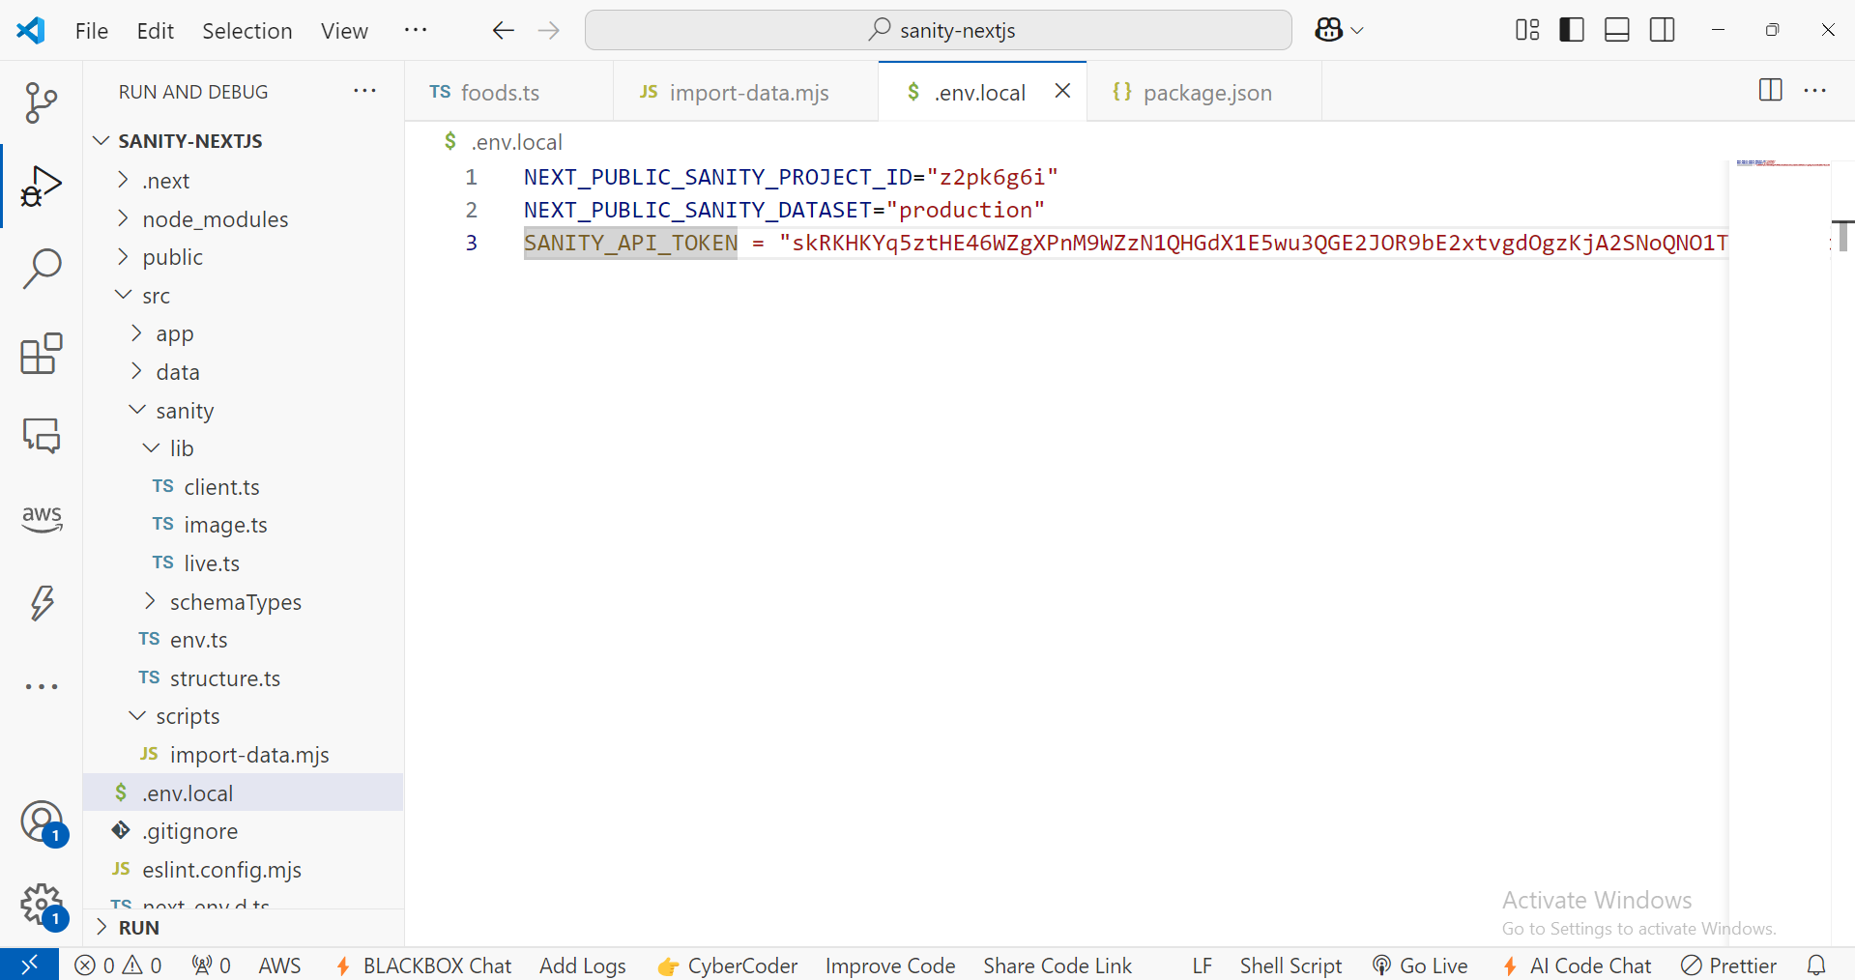

1. **Login to sanity account in /studio:**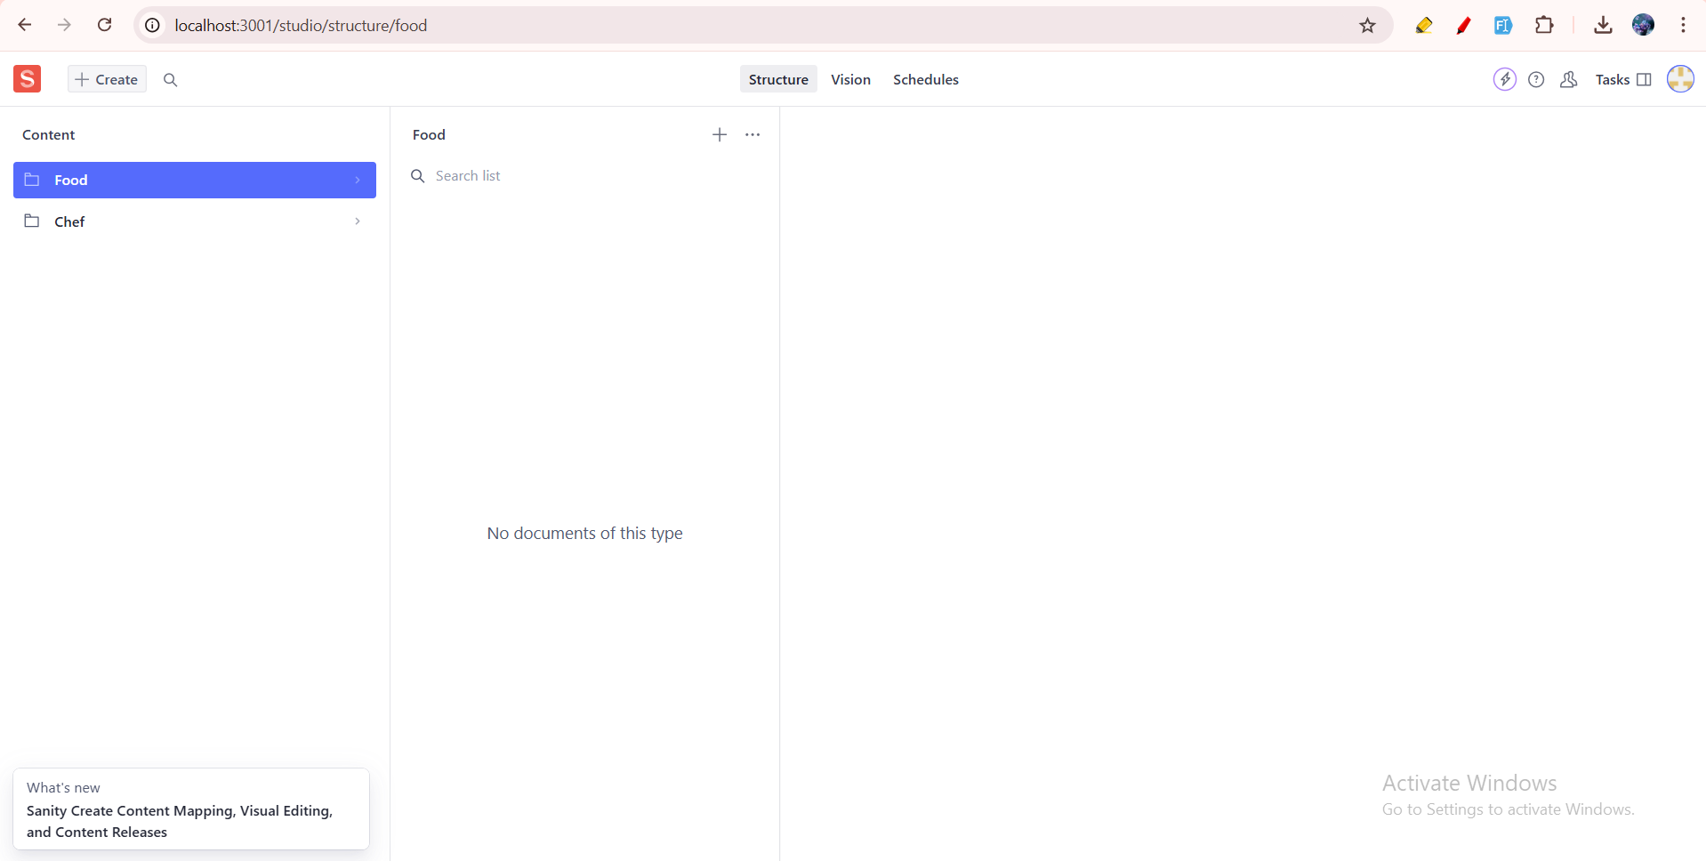

You can see the defined schemas here.

1. **Pass token inside client function in client.ts file.**

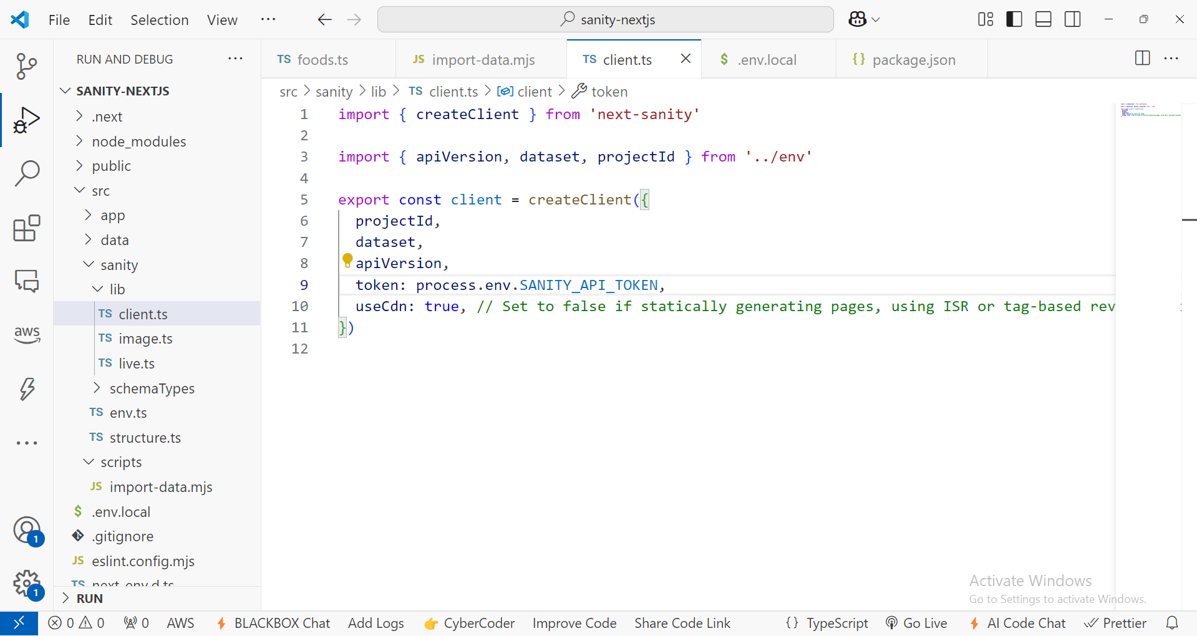

1. **Now, importing the data using script provided inside script folder.**

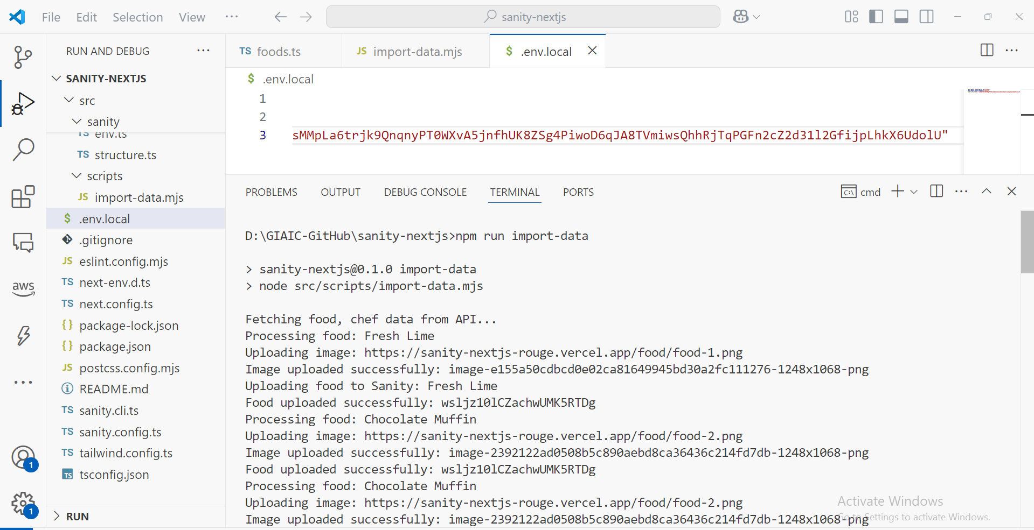

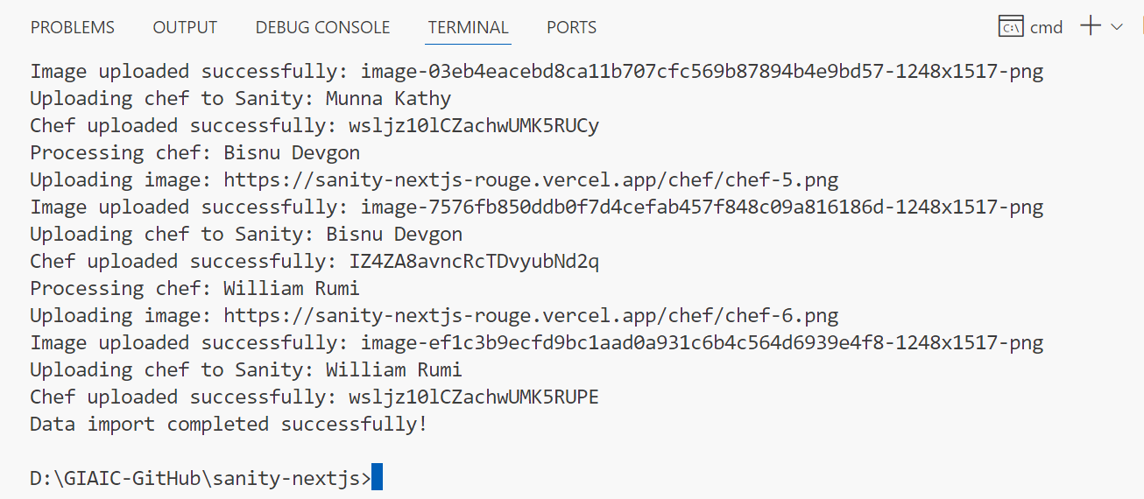

Data imported successfully using the script.

**Food Data in sanity:  
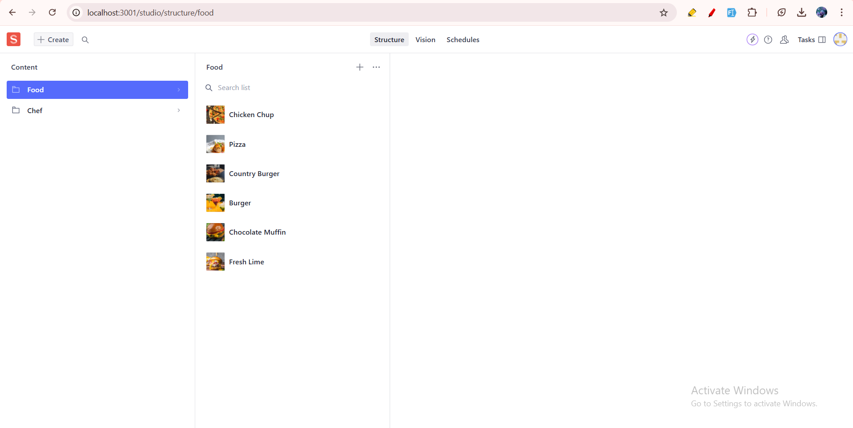  
  
Chefs data in sanity:  
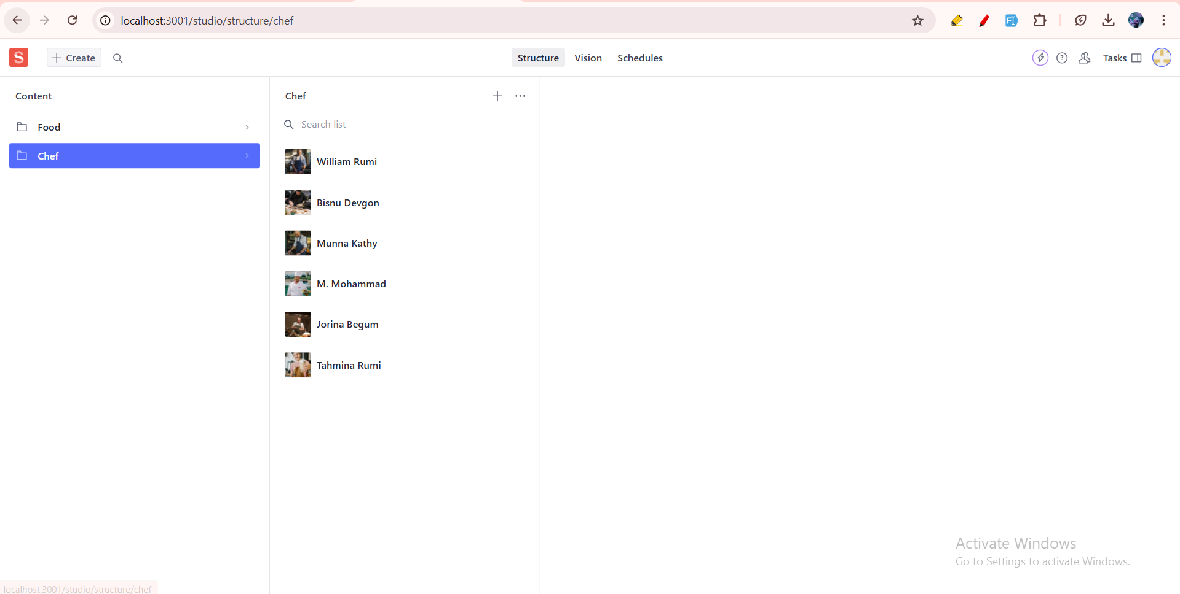**

**Migration Script (import-data.mjs file):**

import { createClient } from '@sanity/client';

import axios from 'axios';

import dotenv from 'dotenv';

import { fileURLToPath } from 'url';

import path from 'path';

// Load environment variables from .env.local

const __filename = fileURLToPath(import.meta.url);

const __dirname = path.dirname(__filename);

dotenv.config({ path: path.resolve(__dirname, '../../.env.local') });

// Create Sanity client

const client = createClient({

  projectId: process.env.NEXT_PUBLIC_SANITY_PROJECT_ID,

  dataset: process.env.NEXT_PUBLIC_SANITY_DATASET,

  useCdn: false,

  token: process.env.SANITY_API_TOKEN,

  apiVersion: '2021-08-31',

});

async function uploadImageToSanity(imageUrl) {

  try {

    console.log(`Uploading image: ${imageUrl}`);

    const response = await axios.get(imageUrl, { responseType: 'arraybuffer' });

    const buffer = Buffer.from(response.data);

    const asset = await client.assets.upload('image', buffer, {

      filename: imageUrl.split('/').pop(),

    });

    console.log(`Image uploaded successfully: ${asset._id}`);

    return asset._id;

  } catch (error) {

    console.error('Failed to upload image:', imageUrl, error);

    return null;

  }

}

async function importData() {

  try {

    console.log('Fetching food, chef data from API...');

    // API endpoint containing  data

    const $Promise = [];

    $Promise.push(

      axios.get('https://sanity-nextjs-rouge.vercel.app/api/foods')

    );

    $Promise.push(

      axios.get('https://sanity-nextjs-rouge.vercel.app/api/chefs')

    );

    const [foodsResponse, chefsResponse] = await Promise.all($Promise);

    const foods = foodsResponse.data;

    const chefs = chefsResponse.data;

    for (const food of foods) {

      console.log(`Processing food: ${food.name}`);

      let imageRef = null;

      if (food.image) {

        imageRef = await uploadImageToSanity(food.image);

      }

      const sanityFood = {

        _type: 'food',

        name: food.name,

        category: food.category || null,

        price: food.price,

        originalPrice: food.originalPrice || null,

        tags: food.tags || [],

        description: food.description || '',

        available: food.available !== undefined ? food.available : true,

        image: imageRef

          ? {

              _type: 'image',

              asset: {

                _type: 'reference',

                _ref: imageRef,

              },

            }

          : undefined,

      };

      console.log('Uploading food to Sanity:', sanityFood.name);

      const result = await client.create(sanityFood);

      console.log(`Food uploaded successfully: ${result._id}`);

    }

    for (const chef of chefs) {

      console.log(`Processing chef: ${chef.name}`);

      let imageRef = null;

      if (chef.image) {

        imageRef = await uploadImageToSanity(chef.image);

      }

      const sanityChef = {

        _type: 'chef',

        name: chef.name,

        position: chef.position || null,

        experience: chef.experience || 0,

        specialty: chef.specialty || '',

        description: chef.description || '',

        available: chef.available !== undefined ? chef.available : true,

        image: imageRef

          ? {

              _type: 'image',

              asset: {

                _type: 'reference',

                _ref: imageRef,

              },

            }

          : undefined,

      };

      console.log('Uploading chef to Sanity:', sanityChef.name);

      const result = await client.create(sanityChef);

      console.log(`Chef uploaded successfully: ${result._id}`);

    }

    console.log('Data import completed successfully!');

  } catch (error) {

    console.error('Error importing data:', error);

  }

}

importData();

**- API Integration Code Snippets:**

**Food Category Component API Integration Code (Home page):**

"use client";

import { Great_Vibes } from "@next/font/google";

import { useEffect, useState } from "react";

import { getAllCategories } from "@/sanity/lib/data";

import { ICategory } from "@/sanity/lib/interfaces";

const greatVibes = Great_Vibes({

  weight: ["400"],

  subsets: ["latin"],

});

const FoodCategory = () => {

  const [categories, setCategories] = useState<ICategory[]>([]);

  useEffect(() => {

    const fetchCategories = async () => {

      try {

        const data: ICategory[] = await getAllCategories();

        setCategories(data);

      } catch (error) {

        console.error("Error fetching categories:", error);

      }

    };

    fetchCategories();

  }, []);

  return (

    <>

      <div className="sec3 px-[20px] py-[60px] sm:px-[60px] text-white max-w-[1320px] relative lg:h-[600px] mx-auto flex flex-col">

        <div className="flex flex-col items-center">

          <h3

            className={`${greatVibes.className} text-[#FF9F0D] text-[32px] font-bold`}

          >

            Food Category

          </h3>

          <h1

            style={{ fontFamily: "Helvetica, Arial, sans-serif" }}

            className="text-[##FF9F0D] text-[48px] text-center"

          >

            <span>Ch</span>oose Food Item

          </h1>

        </div>

        <div className="grid grid-cols-1 sm:grid-cols-2 md:grid-cols-3 lg:grid-cols-4 gap-[40px] justify-items-center">

          {categories.slice(0, 4).map((category) => (

            <div

              key={category._id}

              className="max-w-[300px]  relative group cursor-pointer"

            >

              <img

                src={category.imageUrl}

                className="w-[100%] h-[100%] rounded-[6px] object-center object-cover"

                alt={category.name}

              />

              <div className="absolute inset-0 flex justify-center items-center bg-black bg-opacity-50 opacity-0 group-hover:opacity-100 transition-opacity duration-300">

                <div className="text-white text-center flex flex-col gap-[5px]">

                  <div className="rounded-[6px] bg-white px-4 py-3 text-[#FF9F0D] w-fit font-bold text-[18px]">

                  Save 30%

                  </div>

                  <div className="rounded-[6px] bg-[#FF9F0D] text-white px-4 py-3 w-[250px] text-[20px] font-bold">

                    {category.name}

                  </div>

                </div>

              </div>

            </div>

          ))}

        </div>

      </div>

    </>

  );

}

export default FoodCategory;

**Choose & Pick Component API Integration Code (Home page):**

"use client";

import { Great_Vibes } from "@next/font/google";

import { useEffect, useState } from "react";

import { getCategoriesWithFoods } from "@/sanity/lib/data";

import { ICategoryWithFoods } from "@/sanity/lib/interfaces";

const greatVibes = Great_Vibes({

  weight: ["400"],

  subsets: ["latin"],

});

const ChooseAndPick = () => {

  const [categories, setCategories] = useState<ICategoryWithFoods[]>([]);

  const [activeTab, setActiveTab] = useState(0);

  useEffect(() => {

    const fetchCategoriesWithFoods = async () => {

      try {

        const data = await getCategoriesWithFoods();

        setCategories(data);

      } catch (error) {

        console.error("Error fetching categories with foods:", error);

      }

    };

    fetchCategoriesWithFoods();

  }, []);

  return (

    <>

      <div className="sec6 px-[20px] sm:px-[60px] py-[60px] max-w-[1320px] lg:h-[800px] mx-auto flex items-center justify-center">

        <div className="mt-8">

          <div className="flex flex-col items-center">

            <h5

              className={`${greatVibes.className} text-[32px] text-[#FF9F0D] font-normal `}

            >

              Choose & pick

            </h5>

            <h2

              className="text-white text-[48px] font-bold text-center"

              style={{ fontFamily: "Helvetica, Arial, sans-serif" }}

            >

              <span className="text-[#FF9F0D]">Fr</span>om Our Menu

            </h2>

          </div>

          <div className="flex md:flex-row flex-col">

            {categories.map((category, index) => (

              <button

                key={category._id}

                className={`flex-1 py-2 text-center font-medium text-lg ${activeTab === index ? "border-b-2 border-blue-500 text-blue-500" : "text-gray-500 hover:text-blue-500"}`}

                onClick={() => setActiveTab(index)}

              >

                {category.name}

              </button>

            ))}

          </div>

          <div className="p-4 text-gray-700 flex flex-col items-center">

            <div className="grid grid-cols-1 sm:grid-cols-2 lg:grid-cols-3 gap-4 items-center">

              <div className="col-span-1 md:col-span-1 w-[100%] lg:max-w-[300px] h-[330px] relative group cursor-pointer w-full ">

                <img

                  src={categories[activeTab]?.imageUrl}

                  className="w-[100%] h-[100%] rounded-[6px] object-center object-cover"

                  alt=""

                />

                <div className="absolute inset-0 flex justify-center items-center bg-black bg-opacity-50 opacity-0 group-hover:opacity-100 transition-opacity duration-300">

                  <div className="text-white text-center flex flex-col gap-[5px]">

                    <div className="rounded-[6px] bg-white px-4 py-3 text-[#FF9F0D] w-fit font-bold text-[18px]">

                      Save 30%

                    </div>

                    <div className="rounded-[6px] bg-[#FF9F0D] text-white px-4 py-3 w-[250px] text-[20px] font-bold">

                      {categories[activeTab]?.name}

                    </div>

                  </div>

                </div>

              </div>

              <div className="col-span-2 flex flex-wrap gap-[30px] w-full">

                <div className="grid grid-cols-1 sm:grid-cols-2 lg:grid-cols-2 gap-[30px] w-full max-h-[500px] overflow-y-auto">

                  {categories[activeTab]?.foods.map((food) => (

                    <a

                      href={`/shop/${food._id}`}

                      key={food._id}

                      className="flex gap-[20px] cursor-pointer"

                    >

                      <div className="w-[80px] h-[80px]">

                        <img

                          src={food.imageUrl}

                          className="w-[100%] h-[100%] rounded-[6px] object-center object-cover"

                          alt={food.name}

                        />

                      </div>

                      <div className="flex flex-col text-white">

                        <h5 className="font-bold text-[20px]">{food.name}</h5>

                        <p className="m-0 text-[14px] font-normal">

                          {food.description}

                        </p>

                        <p className="m-0 font-bold text-[18px] text-[#FF9F0D]">

                          {food.price} $

                        </p>

                      </div>

                    </a>

                  ))}

                </div>

              </div>

            </div>

          </div>

        </div>

      </div>

    </>

  );

};

export default ChooseAndPick;

**- API Calls (Get data by GROQ query):**

1. **Get All Categories:**

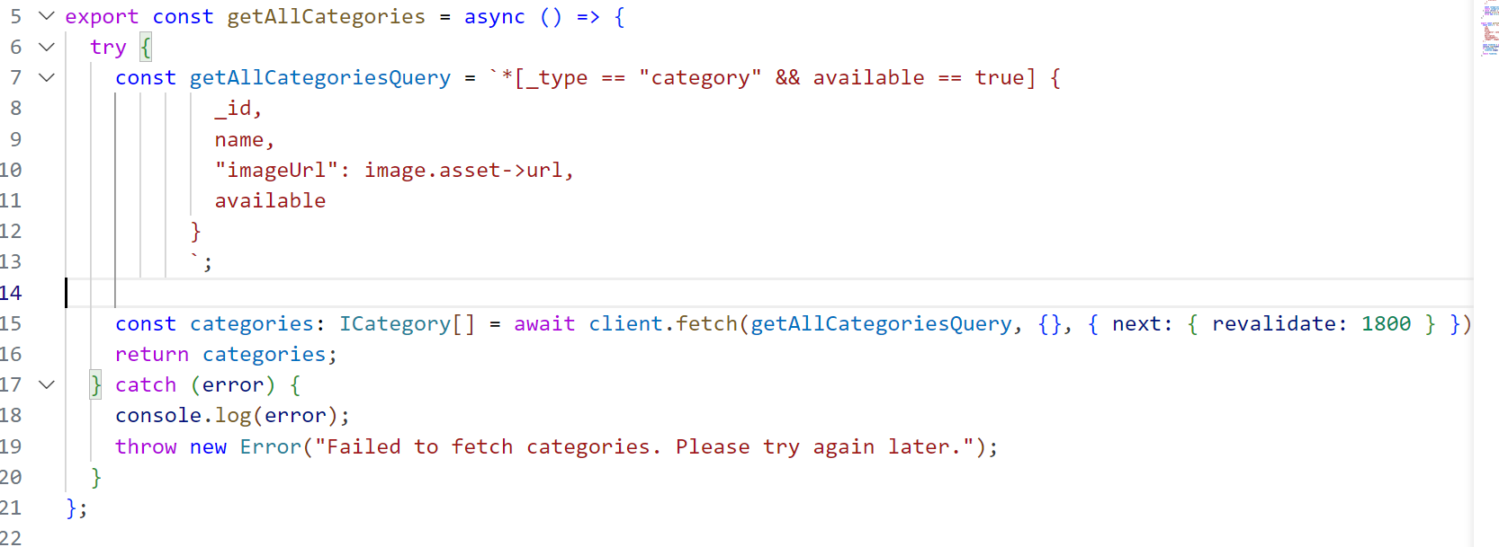

1. **Get all categories data along with food items:**

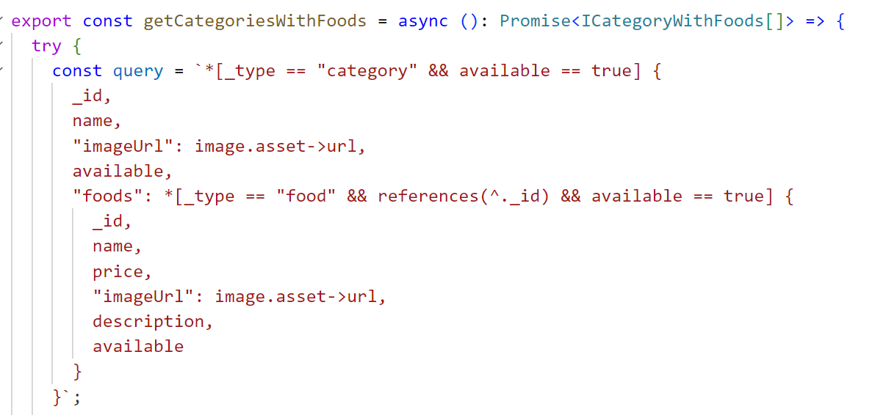

1. **Get single food item details:**

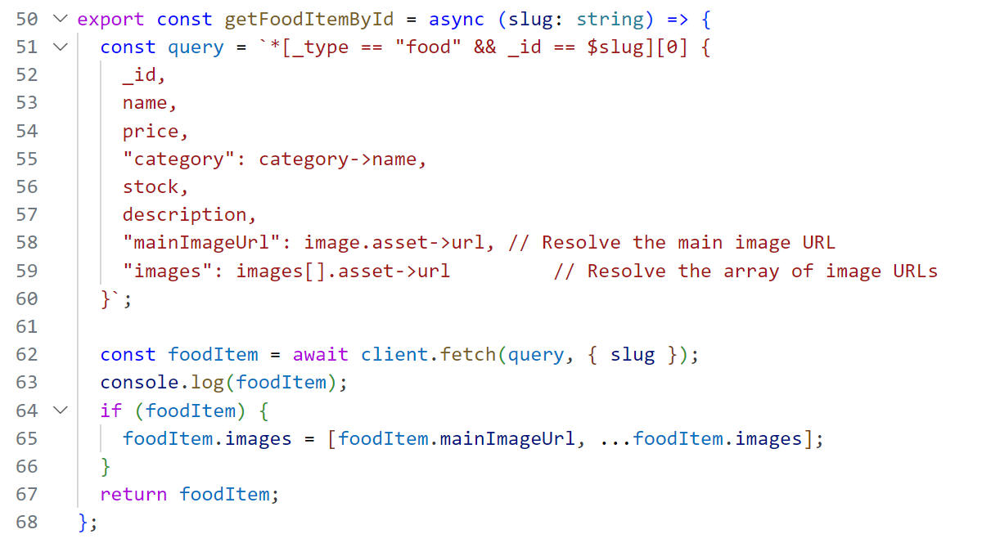

**Data Displayed in Frontend Next JS Website:**

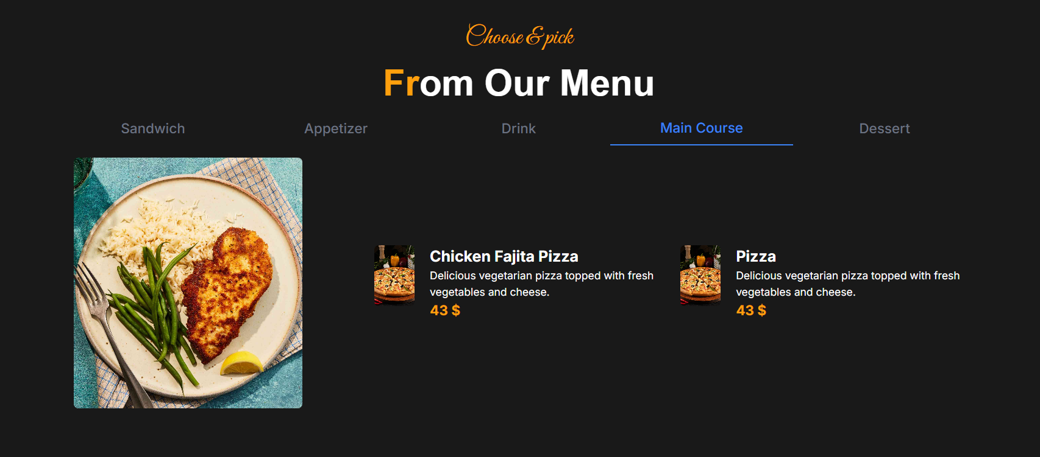

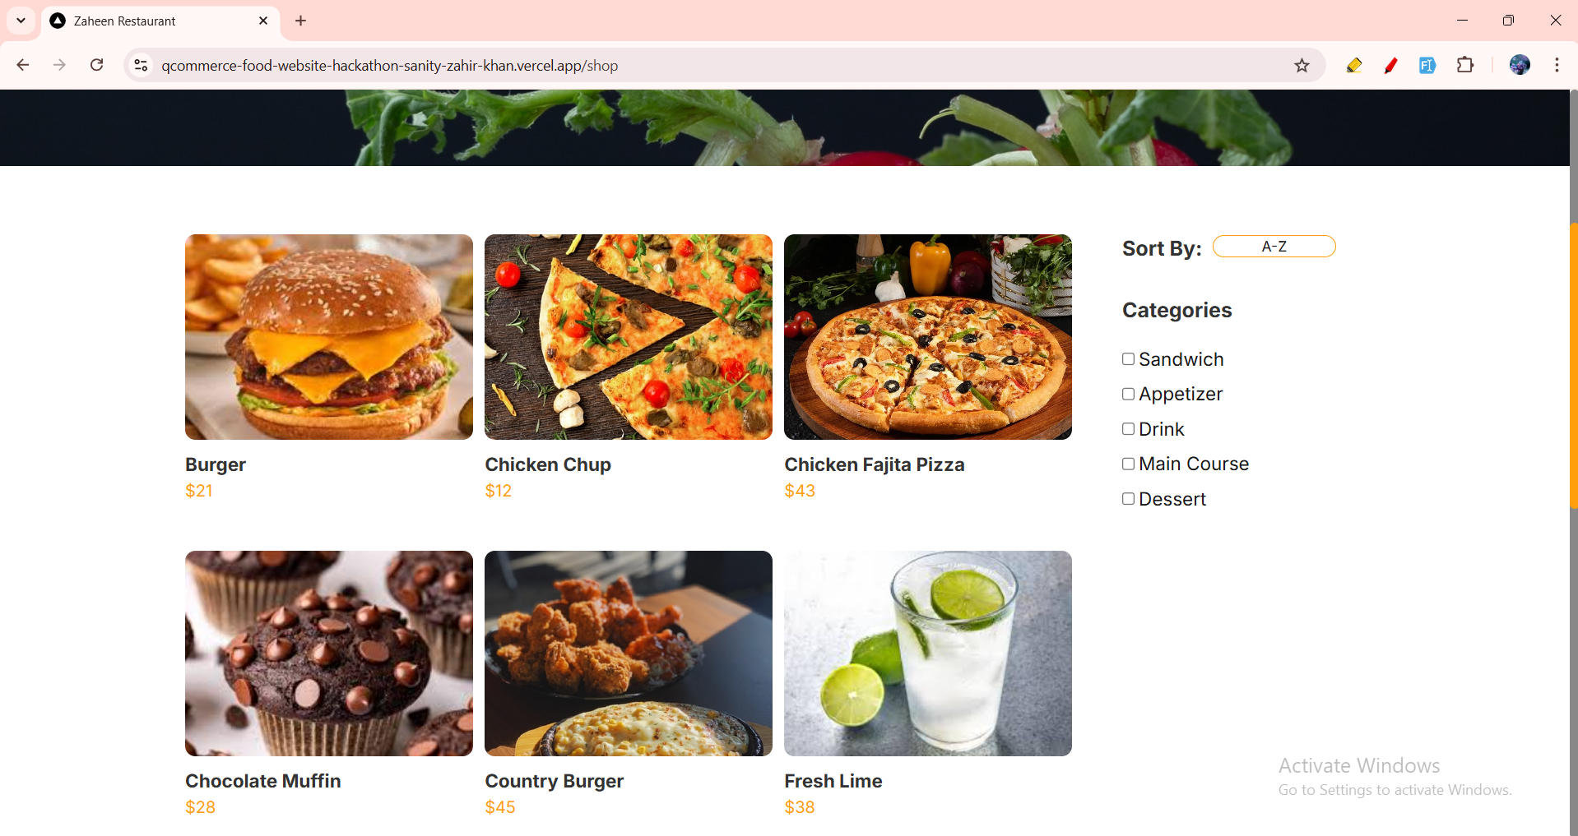

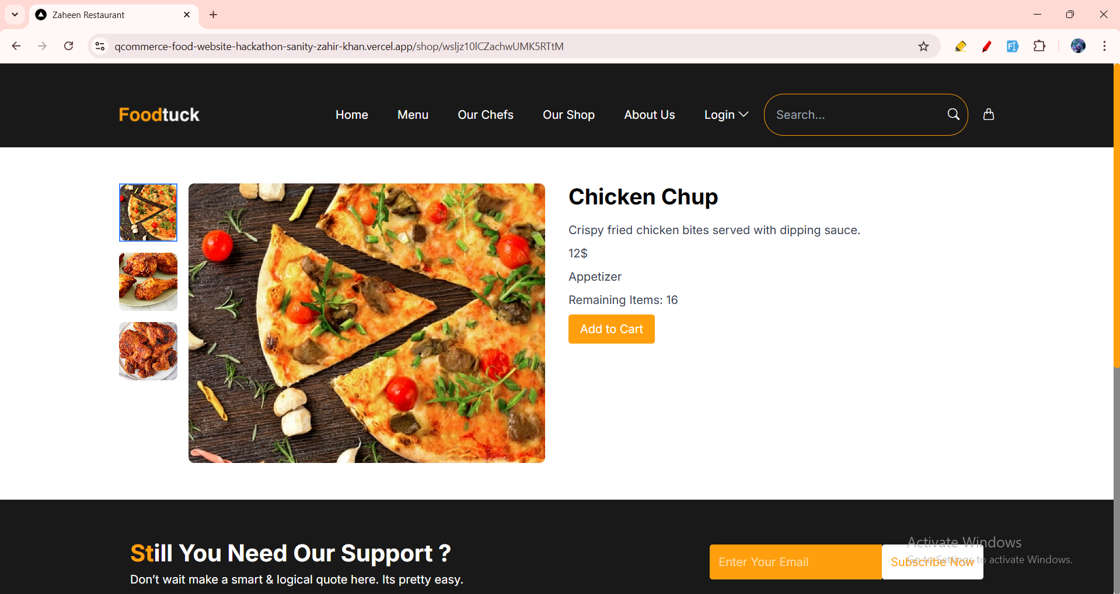

**- Populated Sanity CMS Fields:**  
